2100030130

Creating tables and inserting rows using SQL cli

Outputs using Python with Database Connectivity

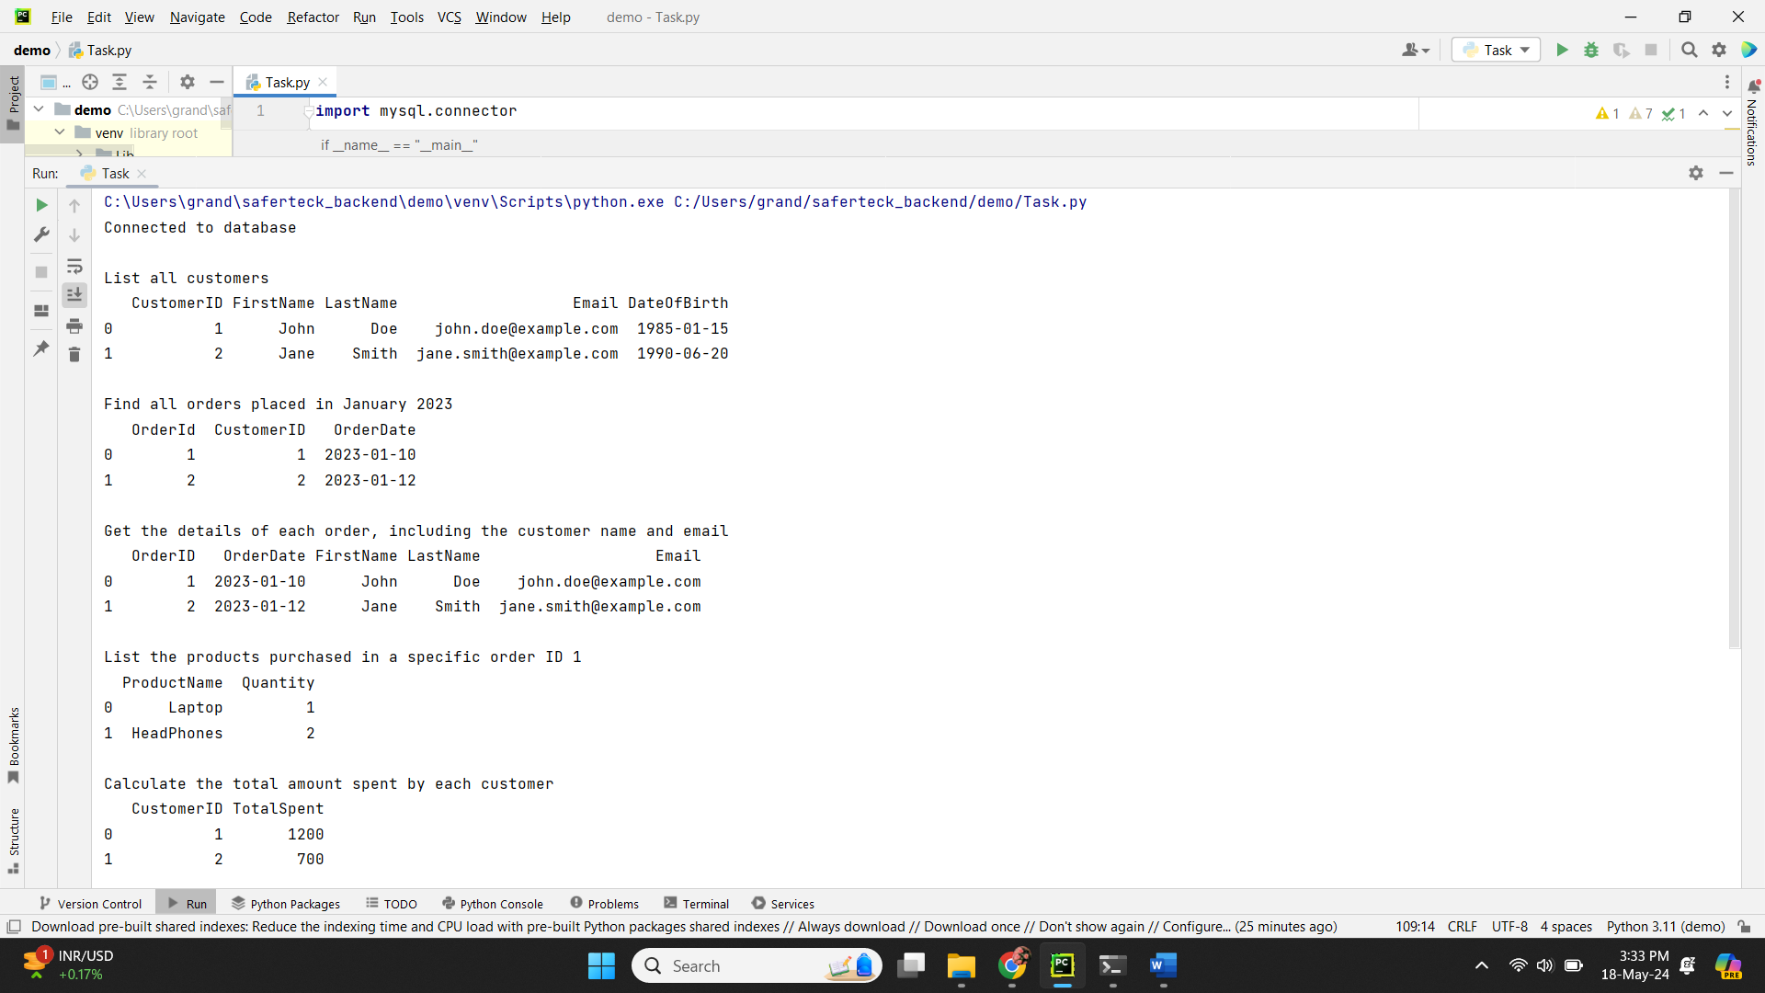

SQL Queries along with output:



